## Lab 3-03: gsutil for Cloud Storage

### Lab Prerequisites

* Familiarity with basic Google Cloud Computing concepts and terminology.
* A Google account with an active subscription.

### Service Introduction

Google Cloud Storage Buckets are objects that allow users to store and manage data objects in the Google Cloud Platform (GCP). Cloud Storage is a fully managed service that provides scalable and durable storage fr objects and files, allowing users to store and access data from anywhere in the world.

GCP Cloud Storage Buckets offer several benefits, including high durability, availability, and scalability. Data in the bucket is automatically replicated across multiple regions and stored redundantly to ensure data is always available.

### Case Study AI Image Generator – Imageprod

Background

Imageprod. is a website that allows users to create images from text using a simple interface. Users can enter text and choose from a variety of design templates to create images with custom fonts, colors, and graphics. The website uses Google Cloud Platform (GCP) for storing the images created by users.

GCP cloud storage is used by Imageprod to store the images created by users securely and reliably. The images are stored in GCP buckets, which are highly durable and scalable storage containers that can handle large amounts of data. Imageprod also uses GCP for other cloud services such as authentication and access control, which helps to ensure the security of user data.

The use of GCP cloud storage allows Imageprod to provide a fast and responsive service to users, with quick image rendering times and reliable storage of the resulting images. This makes Imageprod a convenient and user-friendly tool for creating images from text without the need for advanced design skills or software.

### Business Challenge

Their ML model is still in the training phase. The images created by the model need to be reviewed by the developers to ensure the model works as intended. Furthermore, they also need to secure these images, as there may be some private information shared by the users. Therefore, they are looking for a storage option to store these images along with the text. The images need to be kept for 1-3 months or until a developer has reviewed and manually deleted them.

### Proposed Solution

You have been hired to present a solution for this challenge. As a Cloud Architect, you suggested they use Cloud Storage, but they should create the buckets through the command line to add another layer of protection.

Lab Diagram

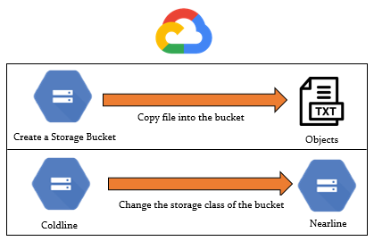

Figure 3-04: Lab diagram

Implementation Steps

1. Create bucket.
2. Copy contents into the bucket.
3. List the bucket's contents.
4. Change the storage class.

Solution

1. Log in to the GCP console and go to “Storage”. Here, you will see our bucket, which has already been created. Go to “Cloud Shell”.

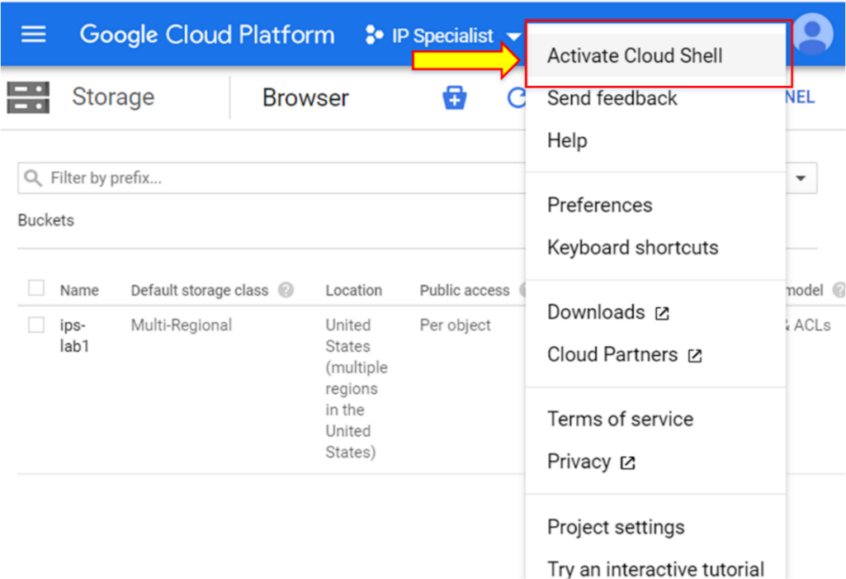

1. Remove the bucket by using the following command: “gsutil rm –r gs://<bucketname>” (-r is used for recursive action in order to delete all the contents within a bucket).

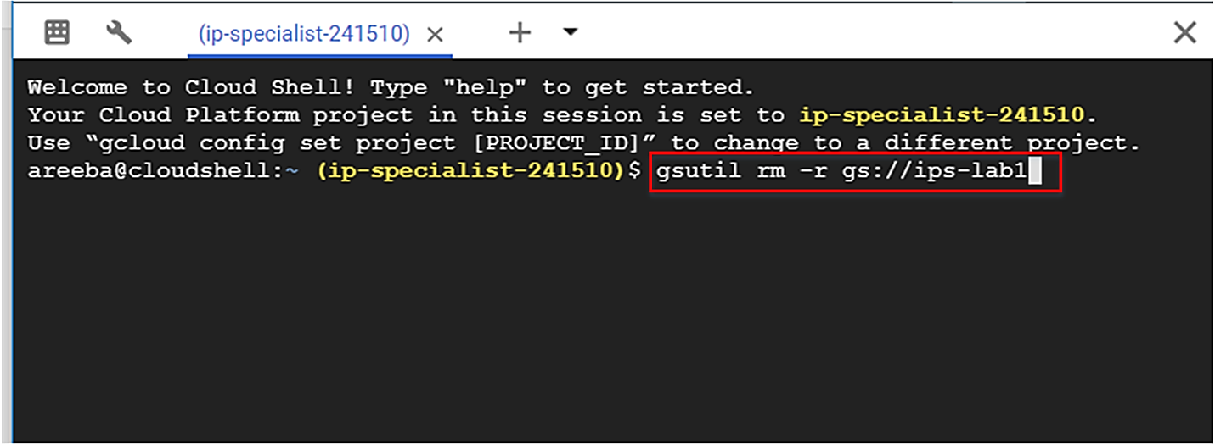

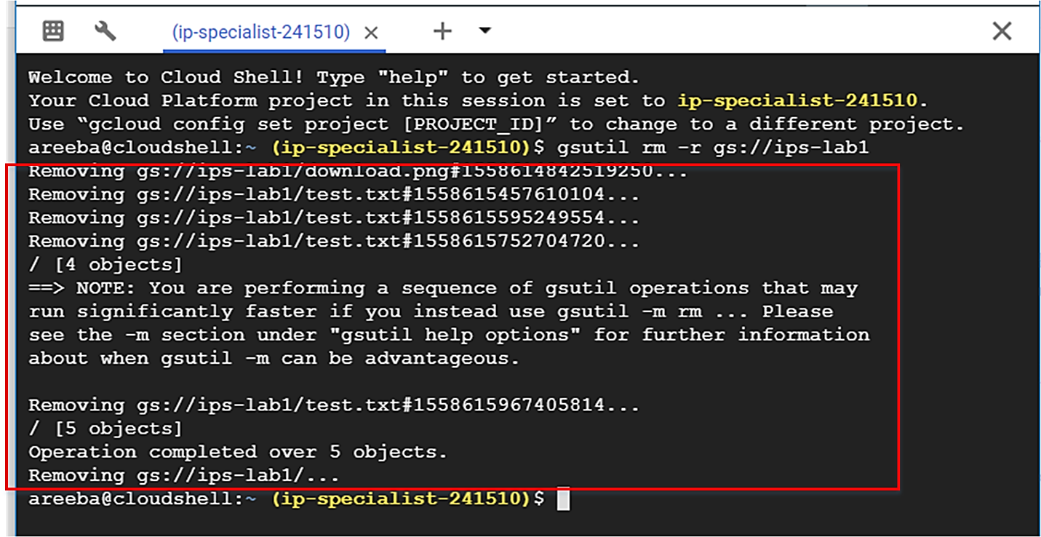

1. Your bucket has been deleted. You can verify this by going into console.

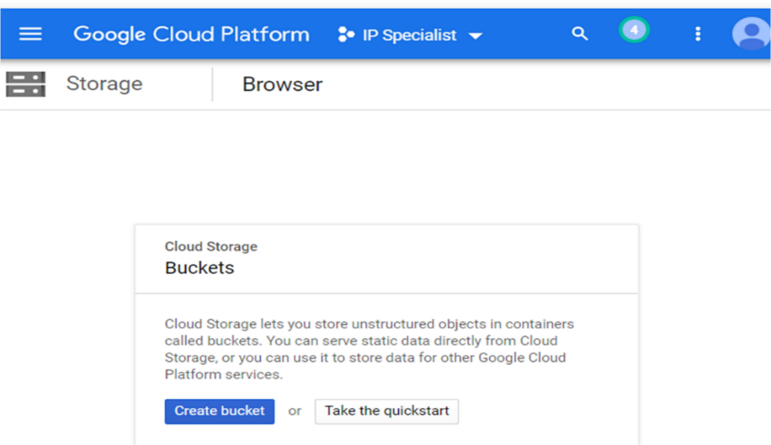

1. Now, create a new bucket with the command “gsutil mb –l <location> -c <class> gs://<bucketname>”. In “–l <location>”, if you define a region, it will make the bucket regional, and if you define multi-regional in location, it will make the bucket multi-regional.

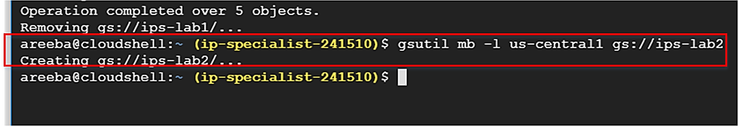

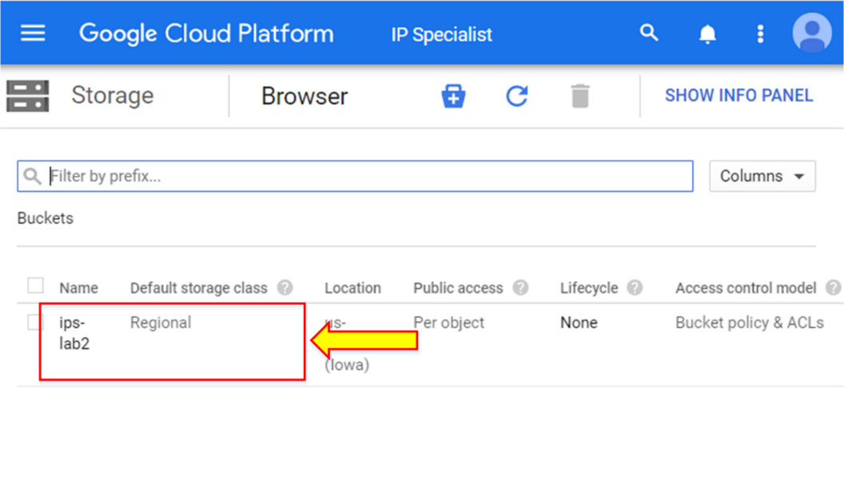

1. After the bucket has been created, copy the content from the local directory to the bucket with the command “gsutil –m cp –r <file/directory> gs://<bucketname>”.

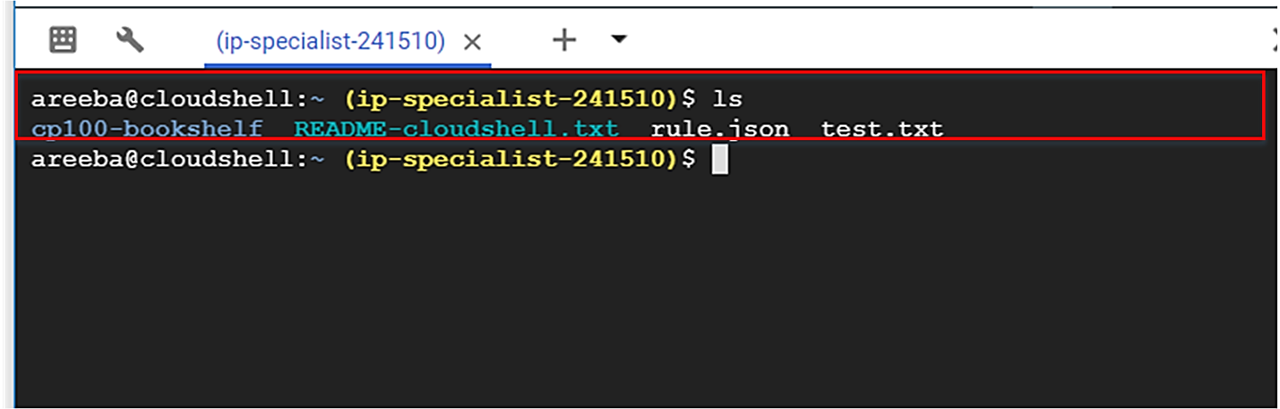

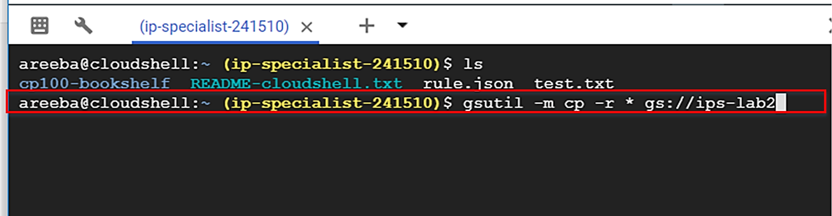

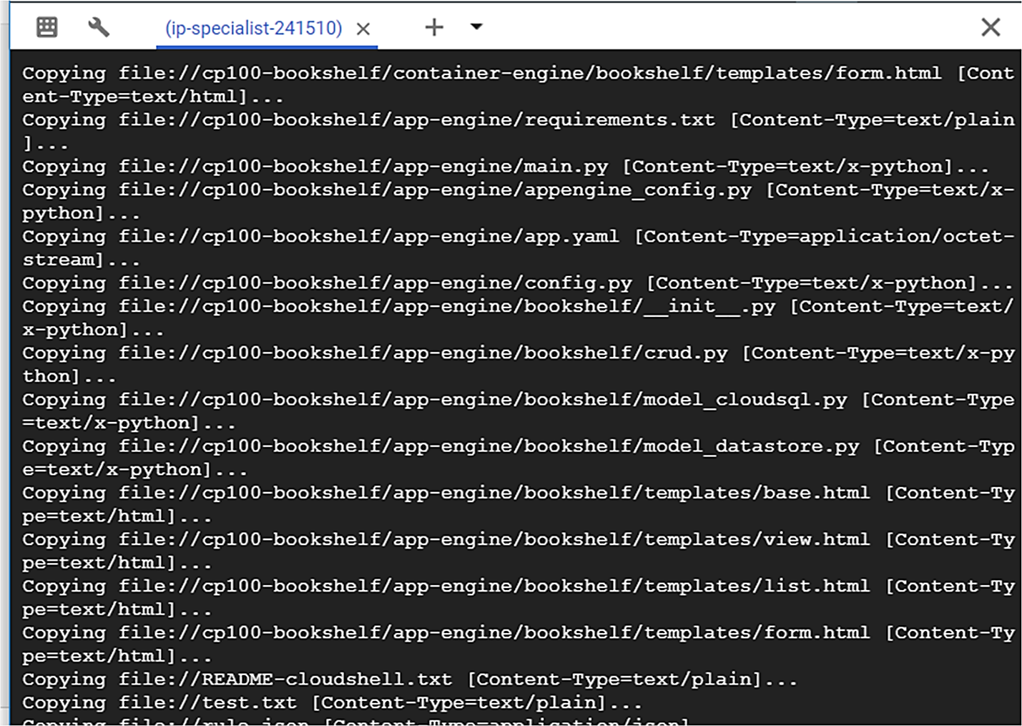

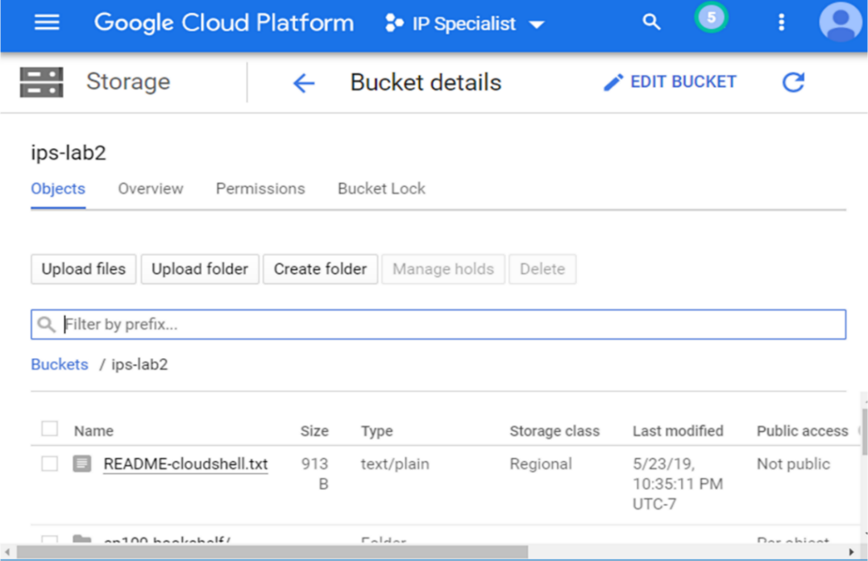

1. Check the versioning status, and if it is disabled, enable it in order to avoid accidental deletion of objects.

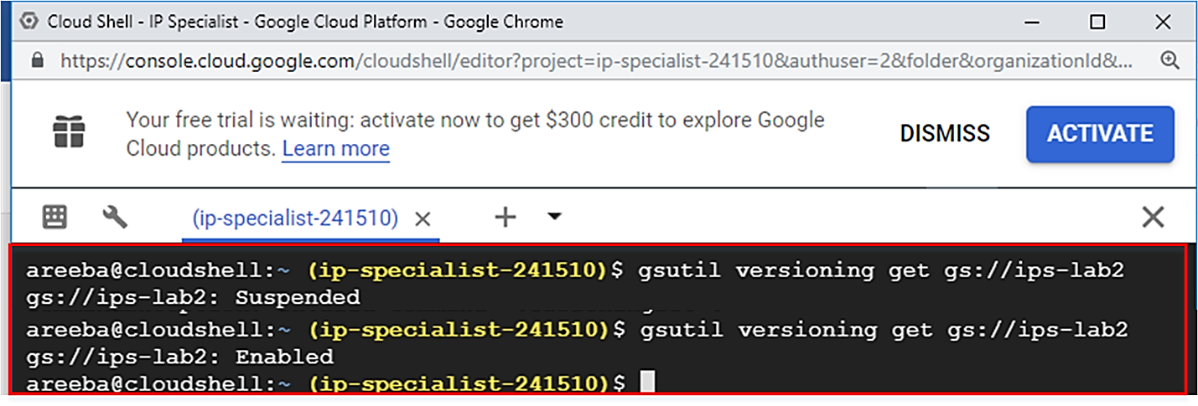

1. To list the bucket content, type the command “gsutil ls gs://<bucketname>”. To see the sub folder inside the bucket, type the command “gsutil ls –r gs://<bucketname>”.

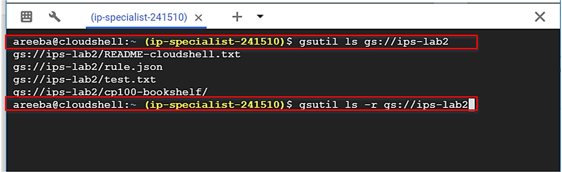

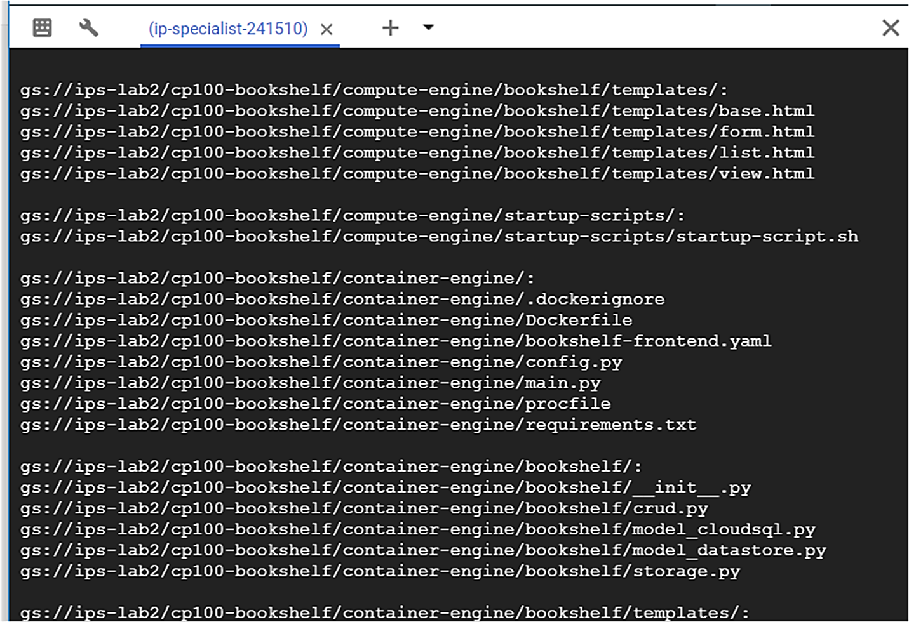

1. Now, change the storage class of the existing bucket and disable the versioning, otherwise a copy of all the objects will be archived.

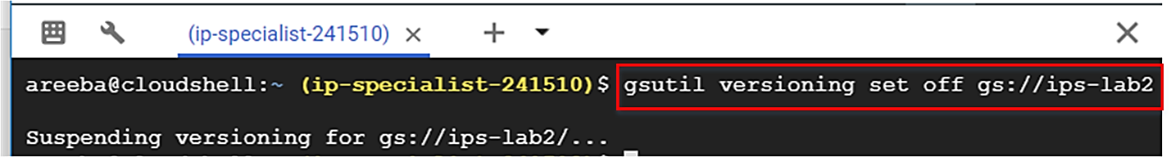

1. To change the storage class, type the command “gsutil –m rewrite –r –s NEARLINE gs://<bucketname>/*”. “/*” is used for all objects inside the bucket.

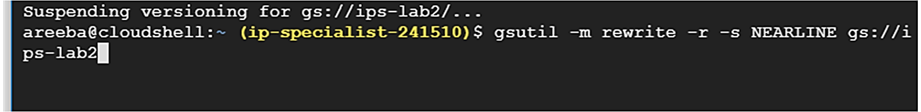

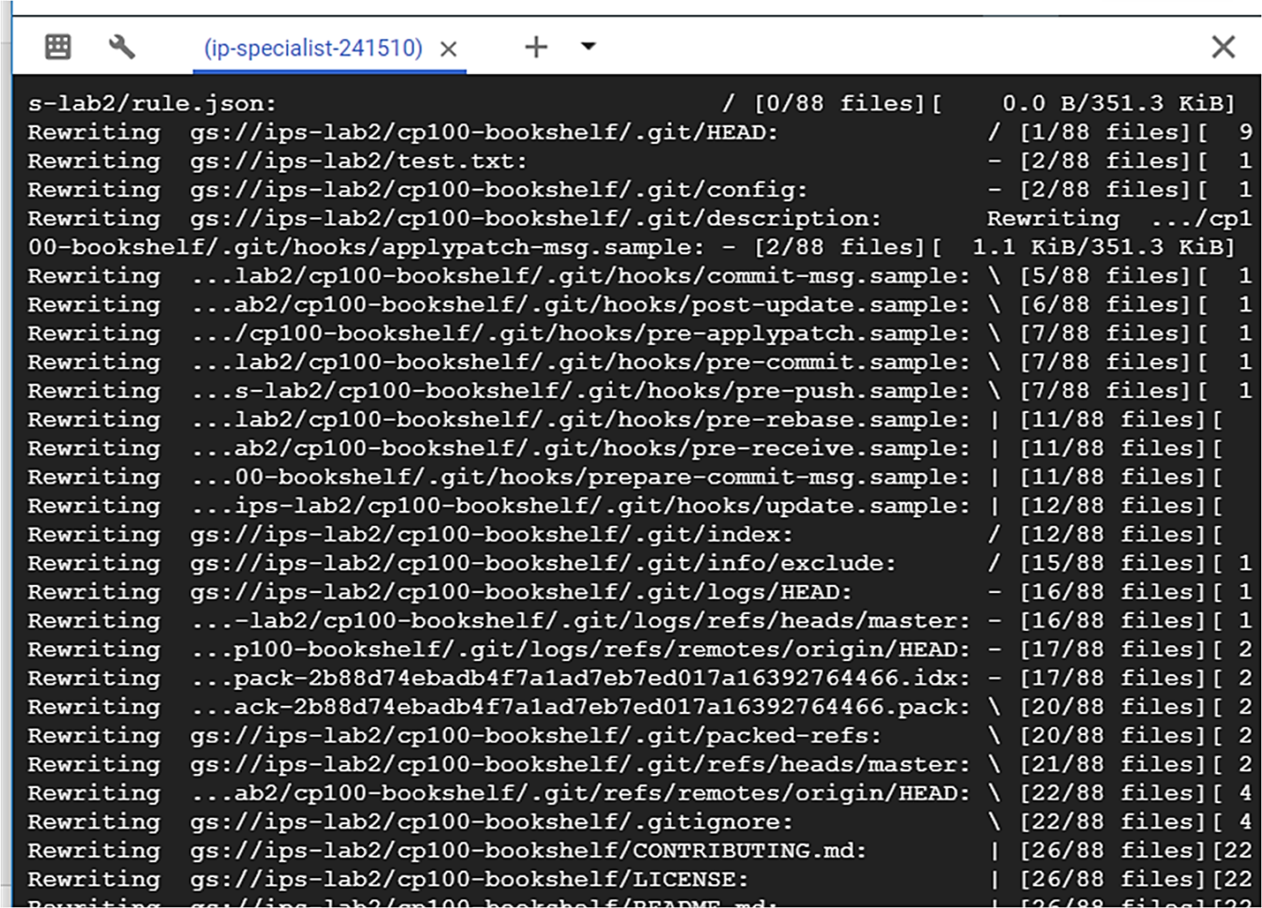

1. You can go to console and see that the storage class is now changed.

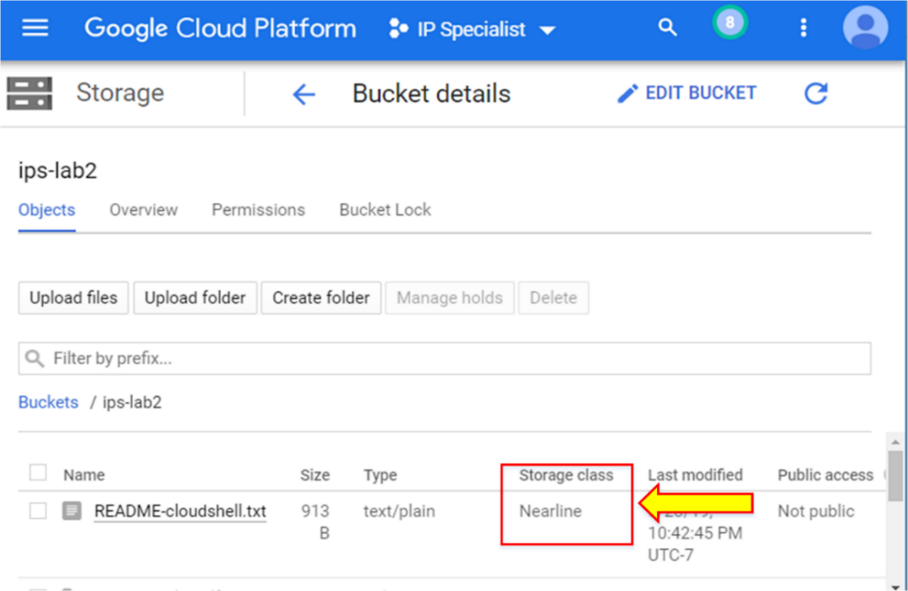

1. To give public access to any of the objects, type the command “gsutil acl ch –u AllUsers:R gs://<bucketname>/<object>”.

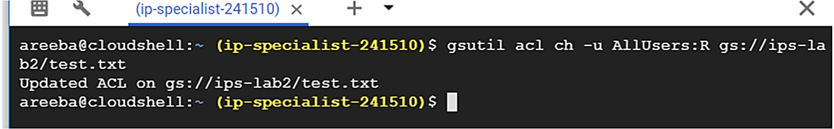

1. Now, go to the GCP console, and there you will see that the file is publically accessible.

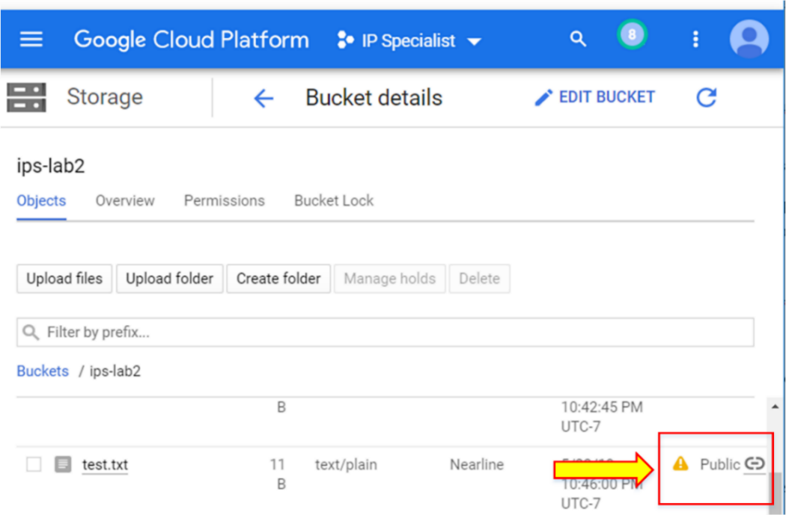

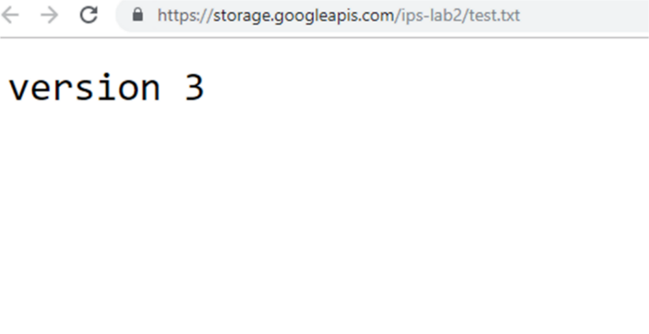

**Note:** To remove public access from the object, type the command “–d” instead of “–u”.